

HH u3a Bulletin number 3
January 2025

Apology
In my last bulletin (number 2), in the 'From the Archives' paragraph I said that our first member with the number 001 was Sarah Tapp's mother Judy - this was incorrect, I should have said that our first member was Sarah Chapman's mother Judy!
I do apologise and I beg the two lady's forgiveness.

Forthcoming Events
Monday 3rd February at Cyprus Hall Burgess Hill, RH15 8DX, is when and where violinist Sarah Milner will be playing some of her favourite music.
Sarah was classically trained but is interested in a variety of other styles and genres.
Entry is free, doors open at 09.45 and her performance starts at 10.30.
Friday 7th February at the HH Methodist Church, Wesley Hall at 10.30 is the place to be to hear Tony Oliver, a Community Support Officer from our local Police Dept. tell us about SCAMs - how to recognise and avoid them.
Entrance is £2 which includes refreshments
Friday 28th February at Court Bushes Community Hub, Willow Way, Hurspierpoint BN6 9TH at 2pm.is where and when Colin Bostock-Smith will be recalling anecdotes from his 35 year career working in the world of TV, stage and radio where he wrote scripts for Bob Monkhouse, David Jason, Russ Abbott, The Two Ronnies and others from the world of entertainment.
Entrance is £2 which includes refreshments - card payment preferred - take your membership card.

Stories from the Clink Report
Last Friday 24th Neil Sadler's 'Stories from the Clink' attracted 46 members who defied the rain, wind, and assorted typhoons and hurricanes to be enthralled by Neil who entertained us all with his amusing stories and anecdotes from his time in the Police force. All agreed that Neil was an an excellent speaker and we look forward to hearing another of his talks in the not-too-distant future.

Bowls opportunity
St. Francis Bowls Club are looking to recruit new members and so they have issued an invitation to HH u3a members to a free 'taster' event on Wednesday 23rd April at 2pm.
At the event you will be provided with some basic instruction and the loan of bowls.
Casual dress may be worn but please take flat soled shoes.
The normal annual club membership fee is £130, but any u3a member who joins the club will be offered a 'special' first season membership fee of £75. The season runs from mid-April until the end of September.
Refreshments will be provided and a free car park is available.
St Francis Bowls Club is situated in pleasant surroundings in the grounds of the Princess Royal Hospital. The bowls club has it's own Pavilion and six quality grass rinks.
To register your interest please email timothy.cole@hotmail.co.uk

Nature Walkers first walk of 2025

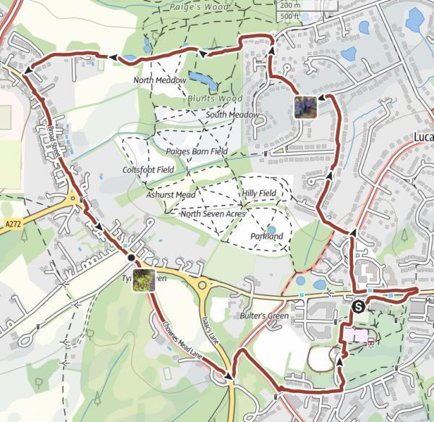
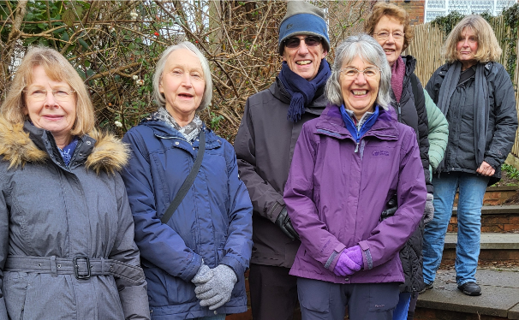

On Thursday 16 January, Polly, Geraldine, John, Marilyn, Ruth & Janet enjoyed 'Balmy weather' for their first walk of 2025. It took a leisurely 1 hour and 23mins to complete the circular walk indicated.

Burgess Hill u3a September Holiday
There are still places available on this short break but all single rooms have been taken.
The cost in either a twin or double is £644 per person.
Contact Marilyn Renwick on 01444 232002 or email renwick@onetel.com for further information and a booking form.
The holiday is for 5 days starting on September 23rd and includes - Luxury Coach travel - Half Board accommodation - a return heritage train ride on the Swanage Railway with views of Corfe Castle - a visit to one of the finest privately owned gardens in England at Compton Acres and a Poole Harbour cruise with a cream tea.

Ukulele Concert
On Thursday 16th January, 6 members of the HH u3a Ukulele group entertained the residents of Wellington House Care Home by playing and singing for them.
They were well received by their audience and are looking forward to performing a small part of their extensive repertoire at the Haywards Heath Baptist Church on Thursday 30th January at 2pm.

Some Trivia for you
At the 2021 census, Haywards Heath, which includes Lindfield, had a total population of 40,184 of which 7,714 were over the age of 65. As our current membership - not all from HH and Lindfield and not all over 65 (I did say this was trivia!) - is around 1,000 we represent about 15% of our possible membership demographic.
If all 7,000 were to join us !!!!
Bye for now
Paul

