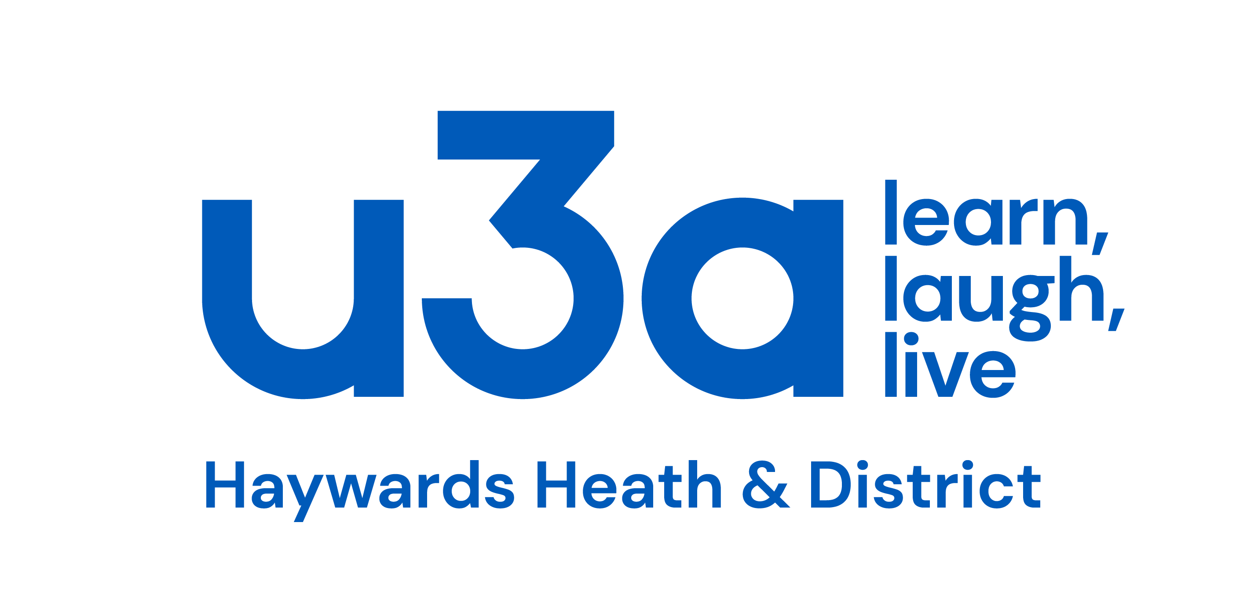

HH u3a Bulletin 1

January 2025

What's occurin'?
Well! we managed to negotiate the Festive Season successfully and now here we are in a brand New Year and I sincerely hope that it’s a happy one for you.
What do we have planned for you in the coming months?
On Friday 24th January at 10.30 in the HH Methodist Church, Wesley Hall, Neil Sadler will be entertaining us with his talk entitled 'Stories from the Clink'. Neil has spoken to us on previous occasions about amusing episodes in his 30 years experience as a senior Police Officer, and very good he is too! Entrance fee is £2 which includes refreshments.
Friday 7th February is when Tony Oliver a Community Support Officer from the local Police Department will be giving a presentation on scams, how to recognise them and how to avoid them. This talk will also be in the Wesley Hall at 10.30 and there is an entrance fee of £2 which includes refreshments.
Yet another Friday! this time it's 28th February. Colin Bostock-Smith is a retired comedy writer who has spent 35 years working in the world of TV, stage and radio. He has written scripts for Bob Monkhouse, David Jason, Anne Robinson, Russ Abbott, The Two Ronnies and others including Basil Brush! Colin will be sharing his successes (and disasters) and you will hear stories about the eccentric individuals we saw on stage and screen in the 80s, 90s and naughties. This presentation will be at Court Bushes Community Hub, Willow Way, Hurstpierpoint, BN6 9TH at 2pm. There is a £2 entry fee (card payment preferred) which includes refreshments. Take your mmembership card.

Walking Cricket
Why not go and try out this fun activity at The Triangle Leisure Centre, Burgess Hill, RH15 8WA on alternate Fridays starting on January 3rd at 11am?
All are welcome.
For more information contact steve.furber@hotmail.co.uk

Bird Watchers
Bird watching group leader Ian Woolgar reported that the final meeting of 2024 at RSPB Pagham Harbour took place on a damp and overcast morning but the tide was right for spotting plenty of waders.
Among the impressive number of 36 individual species seen were:
Avocet Curlew Black-tailed-Godwit Grey Plover Redshank Shoveller Little Egret Great crested Grebe

Winter Warmer
An impressive 40 or so members braved a grey and overcast day to partake of a mince pie or two and a glass or mug of warming refreshment on Friday 13th December.
Not a single Ghoul or Beasty made an appearance and we were all safely back home before it started to get dark!
Much thanks must be extended to Carole, Amanda and Anne for behind -the-scenes work which including the serving and washing up.
Perhaps this could become a regular event?

Holidays
Thinking of your next holiday? Well I'm not going to promote any particular travel company - however!
Thanks very much to the 3 u3a members who booked their 2024 holiday with Riviera Travel. This company, and there maybe others (Fred Olsen for example) has a system called Affinity Discount whereby a small percentage of the cost of the holiday is donated to a charity of your choice. As HH u3a was the holiday maker's charity of choice, we should shortly be receiving around £1,000 from Riviera Travel!! so thanks again.

Gift Aid
Gift Aid is a scheme available to registered charities by which they can claim 25% of the member's subscription from HMRC.
In the financial year 2023 -2024 we received £1,754 into our coffers which came from just 478 members who had indicated that they qualify for Gift Aid because they are UK taxpayers.
As our current membership is 944 we would like to 'sign up' as many of those tax paying members who qualify for Gift Aid but have not yet indicated that fact.
If you are one of those members who have not yet signed up for Gift Aid, you will shortly be receiving information via Beacon about how to rectify this situation and, at no cost to yourself, increase the money we get back as Gift Aid from HMRC.

From the Archive
From 1st September 1992, the annual subscription was set at £10 per person (this is the equivalent of £25.94 today!)
In July 1993 it was decided to ask for a hall hire donation of 50p / person / meeting which is £1.25 in today's money.
Coffee mornings were first implemented in 1994.
At the committee meeting of January 1995, there was a proposal to limit the number of members to 350, this was rejected.
In 1995, the TAT capitation fee was £1.35 - it's now £4.
Our present membership is around 950. Our maximum was in 2019 when we had 1,136 members and during Covid we had shrunk to a little over 750.

In Memoriam
Regretfully, I have four deaths to announce, all having died recently
Keith Foxwell
Keith was a long time u3a member having joined in 1996.
At various times he had been a member of the Gardens group, the Bridge group and one of the Exploring London groups.
Basil (Bob) Campen
Bob had been a member for 10 years and was known to enjoy Scrabble. He has been described as a quiet, lovely man who was a member of Cuckfield Baptist Church. He died peacefully, sadly, within a few days after the death of his wife.
John Barlow
John died mid December. He had been a member of Philosophy, Debating and Discussion groups.
He was knocked down by a car early in 2022.which left him with mobility and cognitive problems but he remained enthusiastic about u3a and attended groups whenever he could manage it.
Betty Hill
Betty, who also died in mid December, had been an enthusiastic member of u3a since 2001.
She had been a member of the Environment and Theatre Goers groups as well as the Jazz Appreciation group.
Our condolences go to their family and friends.

Happy New Year to one and all,
Paul

